DBSE Week -4
EXPERIMENT TITLE:
Bank Transaction Management Using MongoDB Atlas Data Explorer
Created a database Bankdb
with collections: customers and transactions
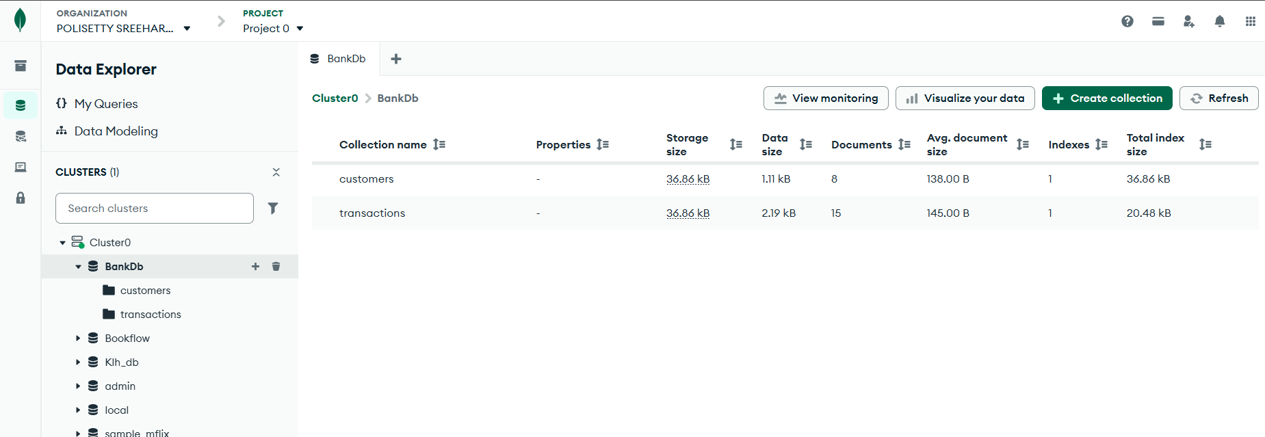
Inserted data into customers and transactions
1) Customers
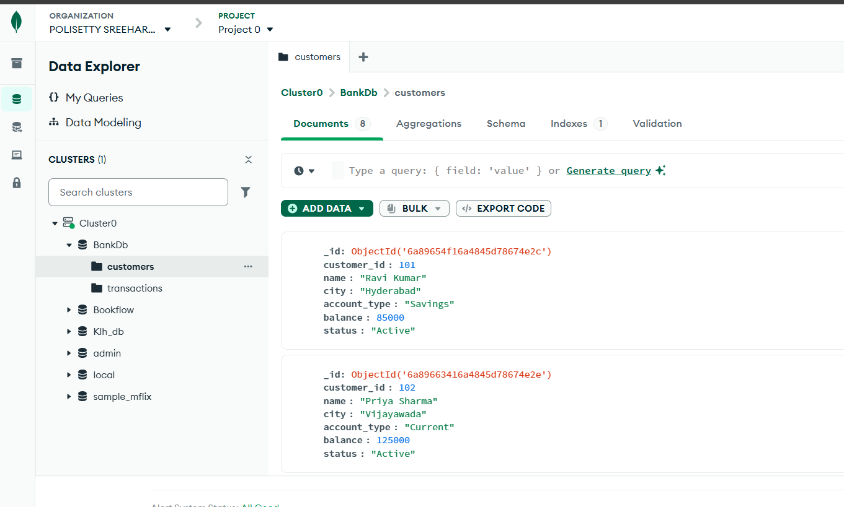
2) Transactions
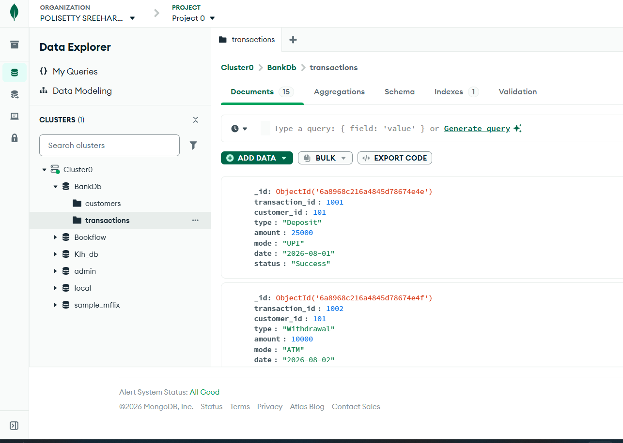
Filter commands used:
1) {} Display’s all customers
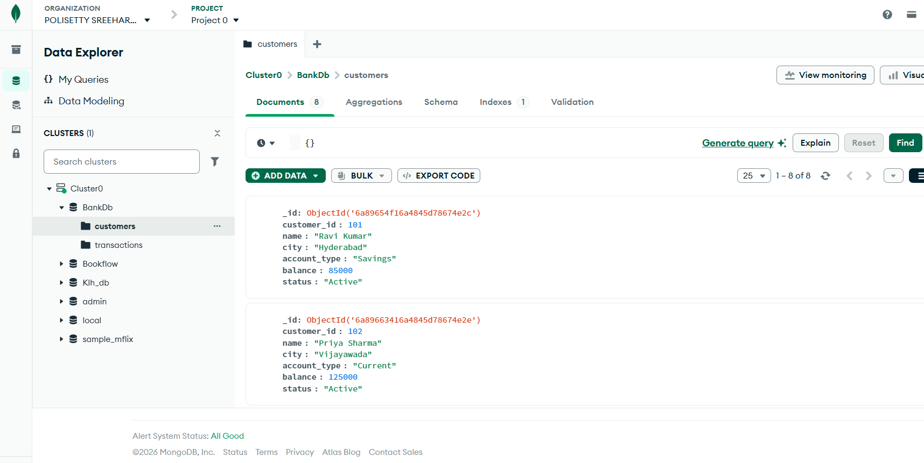
2) FIND ACTIVE CUSTOMERS
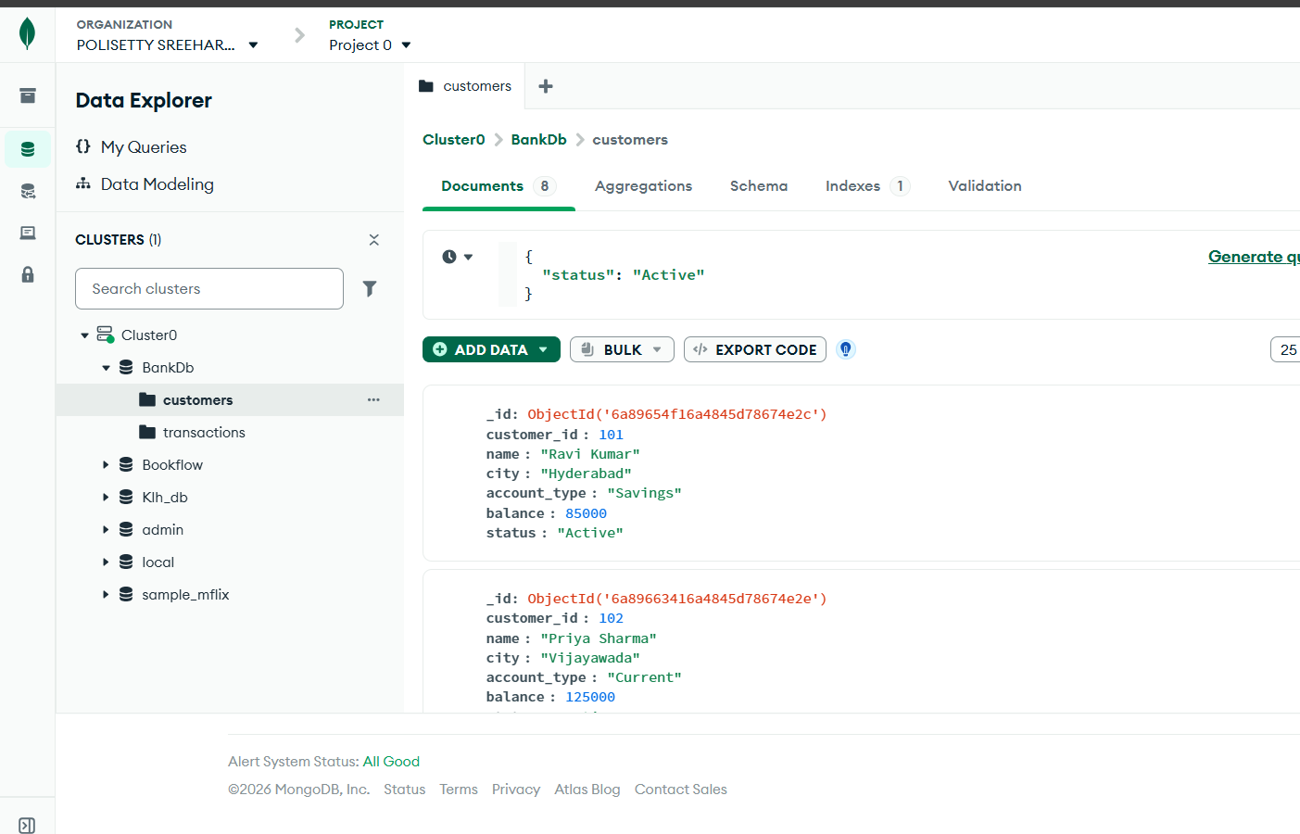
3) FIND CUSTOMERS WITH BALANCE GREATER THAN 100000
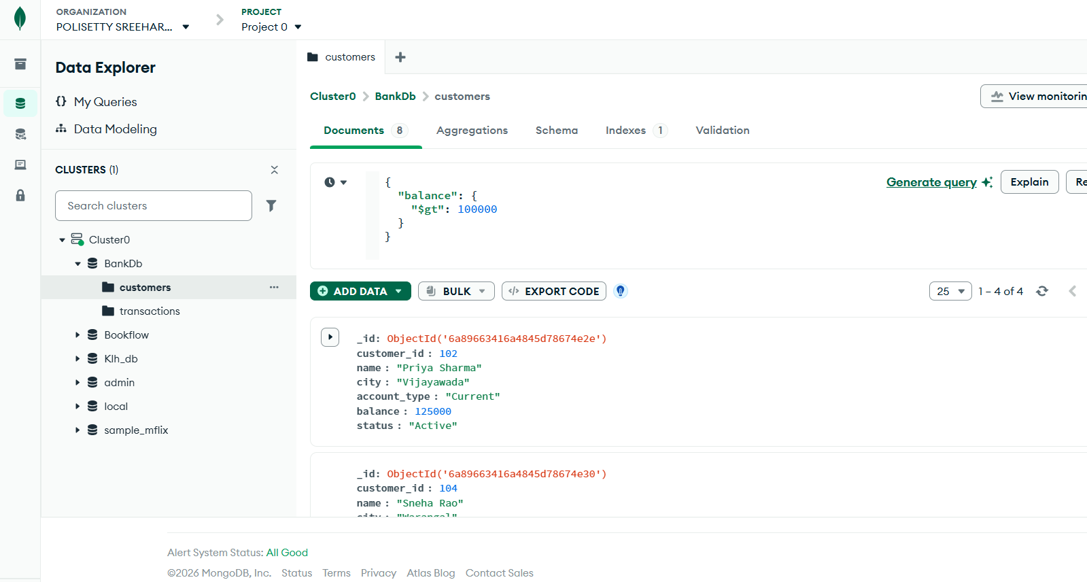
4) FIND HYDERABAD CUSTOMERS
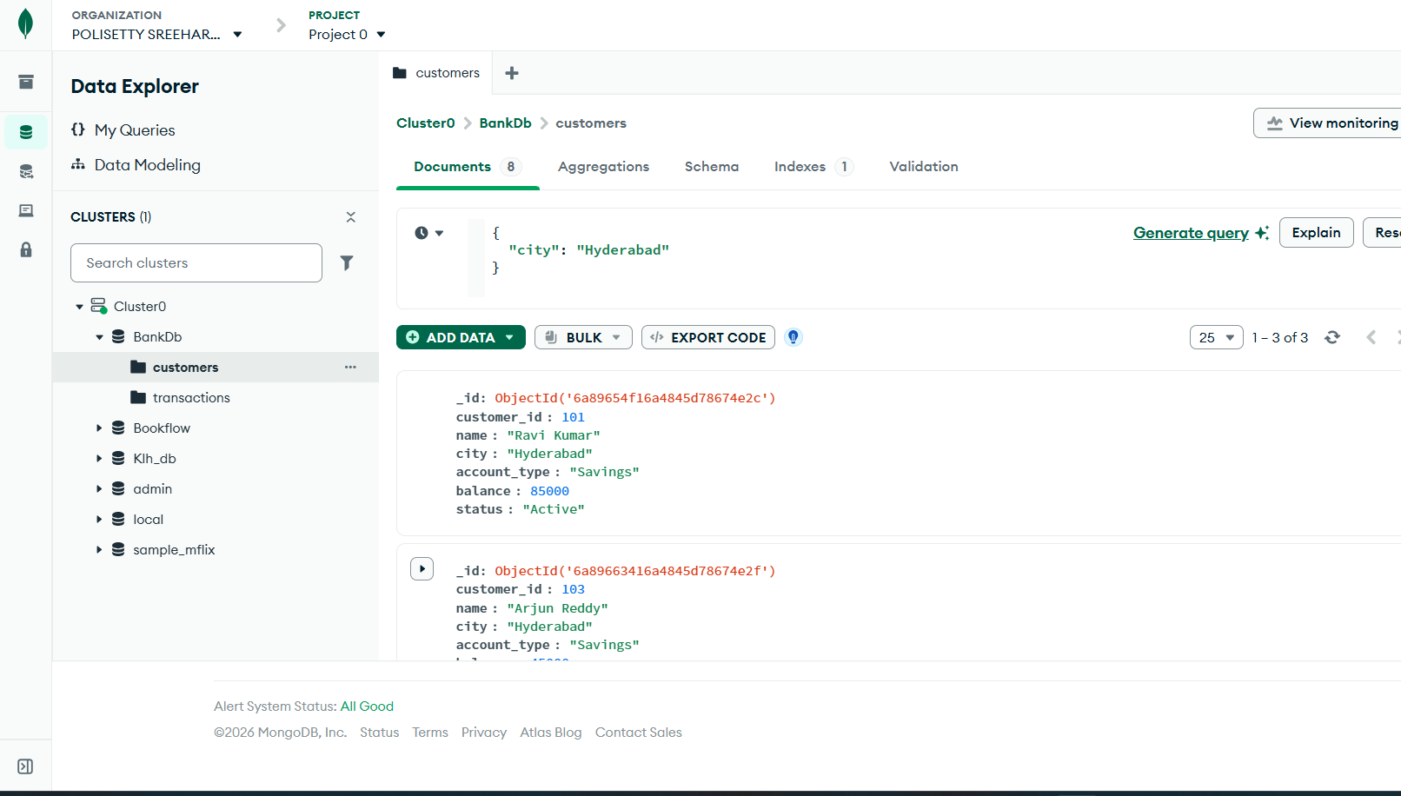
5) FIND SAVINGS ACCOUNT CUSTOMERS
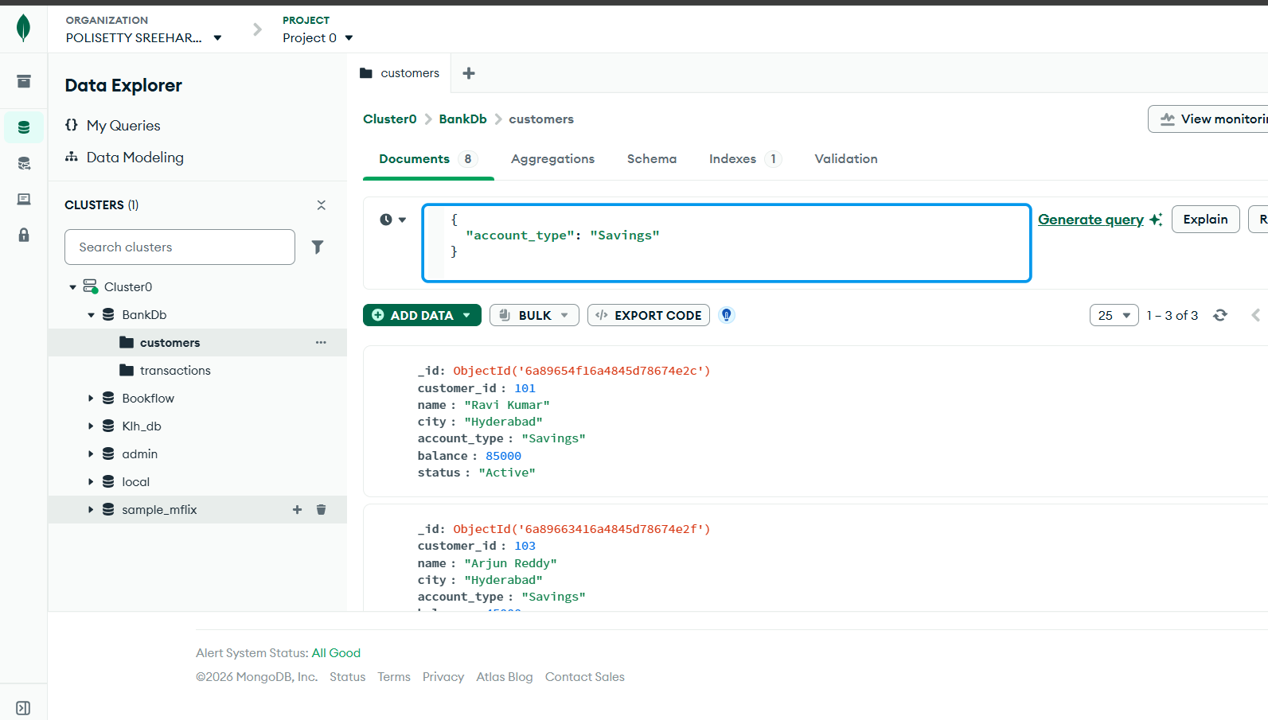
6) FIND TRANSACTIONS GREATER THAN 20000
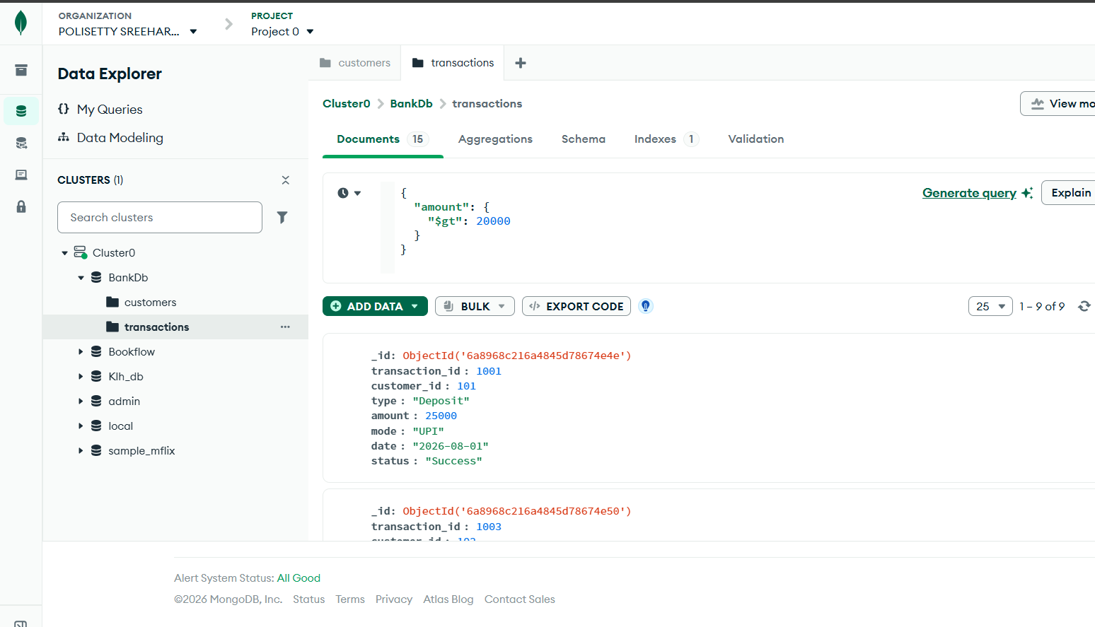
7) FIND DEPOSITS
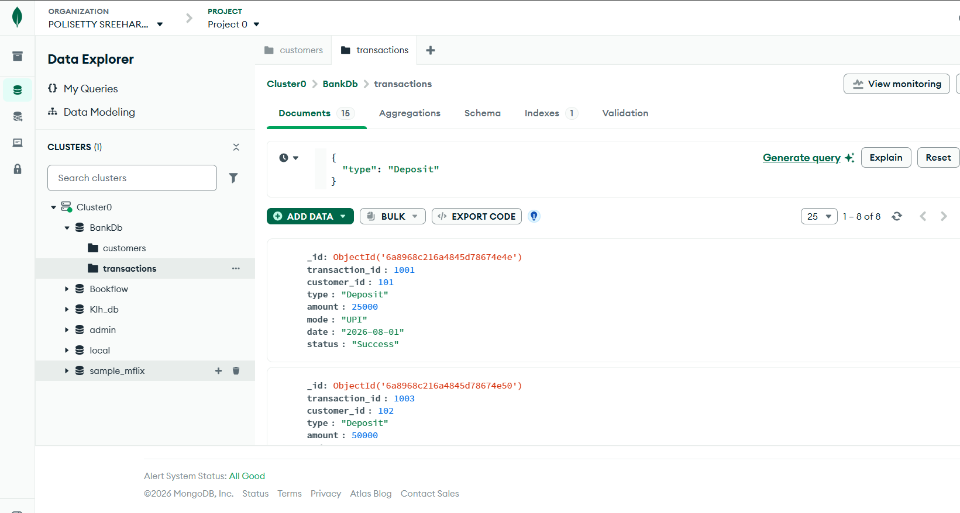
8) FIND ATM TRANSACTIONS
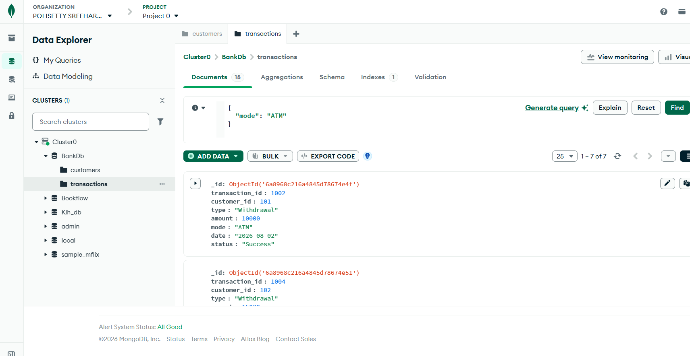
9) FIND DEPOSITS GREATER THAN 50000
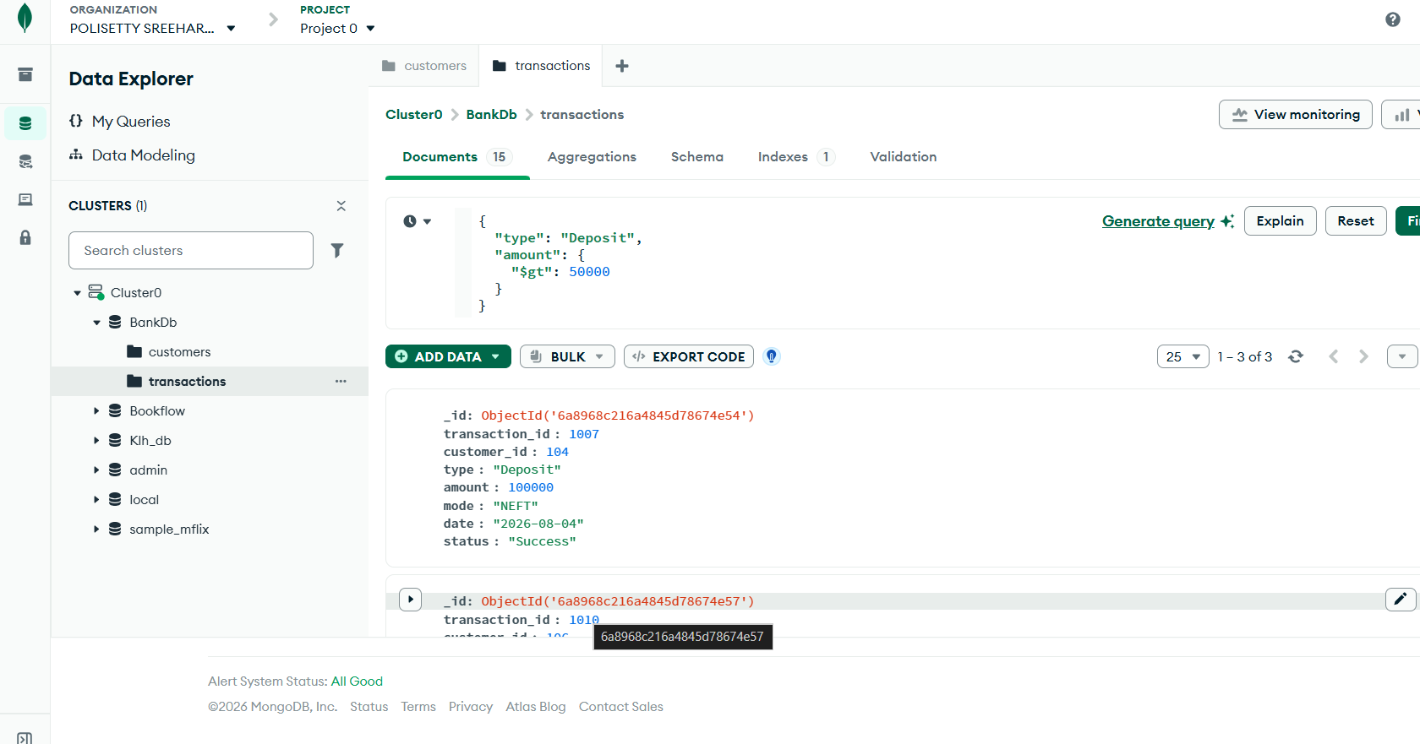
10)FIND HYDERABAD CUSTOMERS WITH HIGH BALANCE
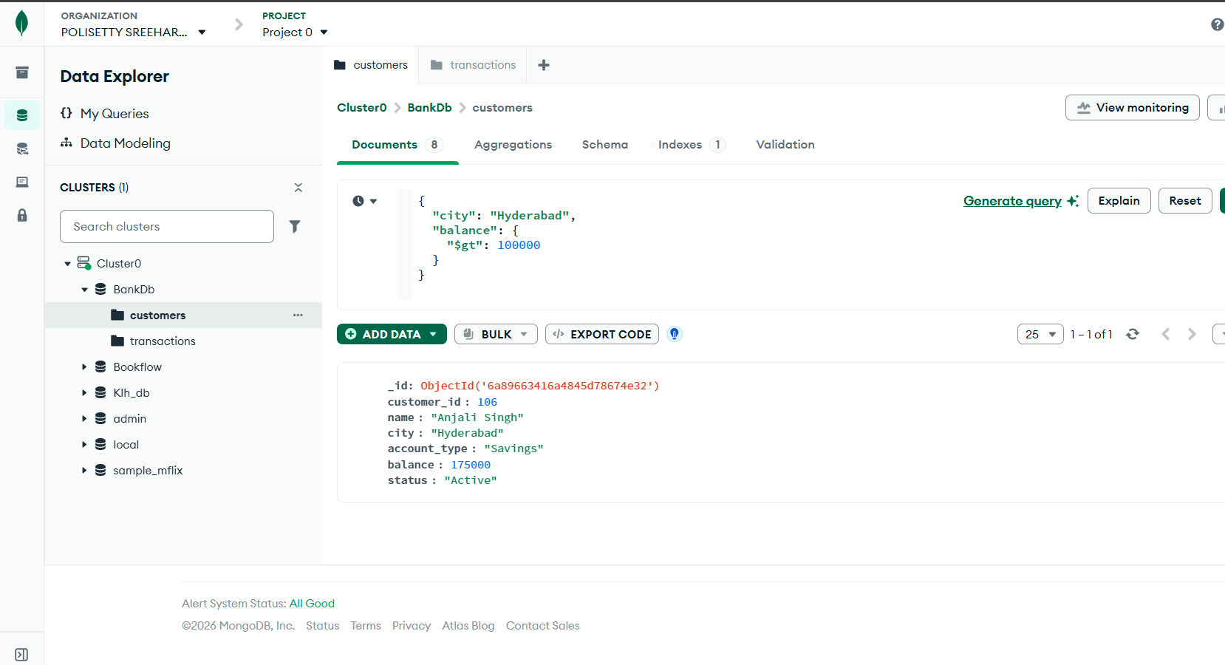
11) FIND CUSTOMERS IN MULTIPLE CITIES
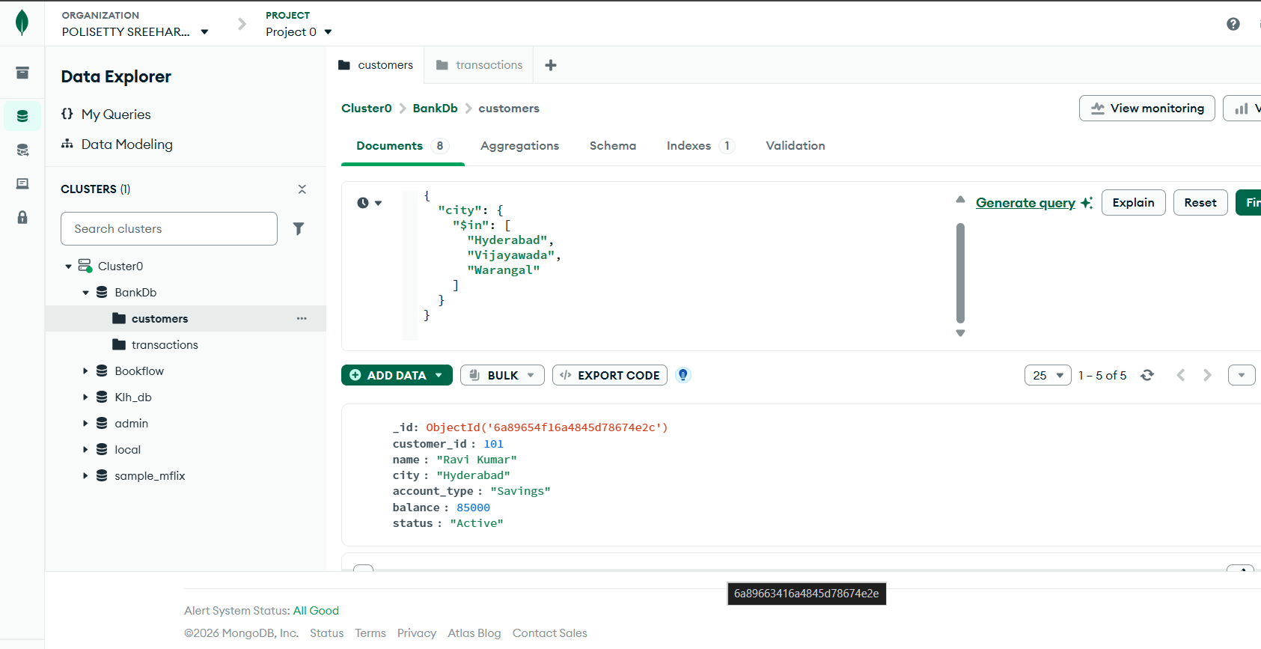

Aggregations
In Customers:
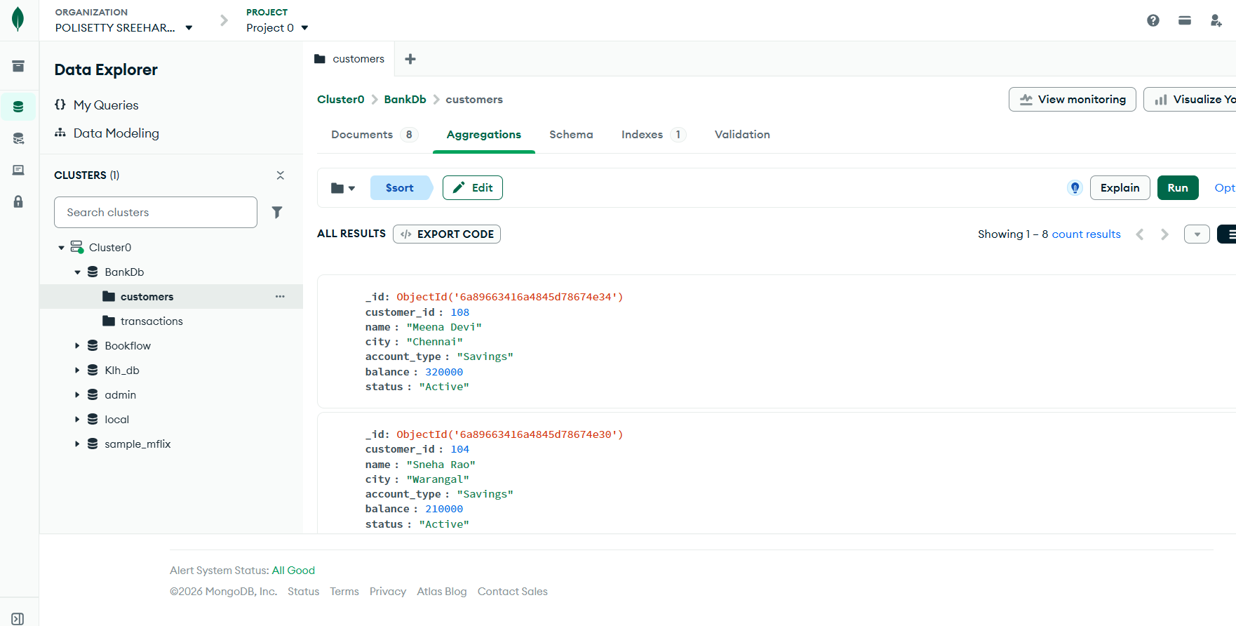
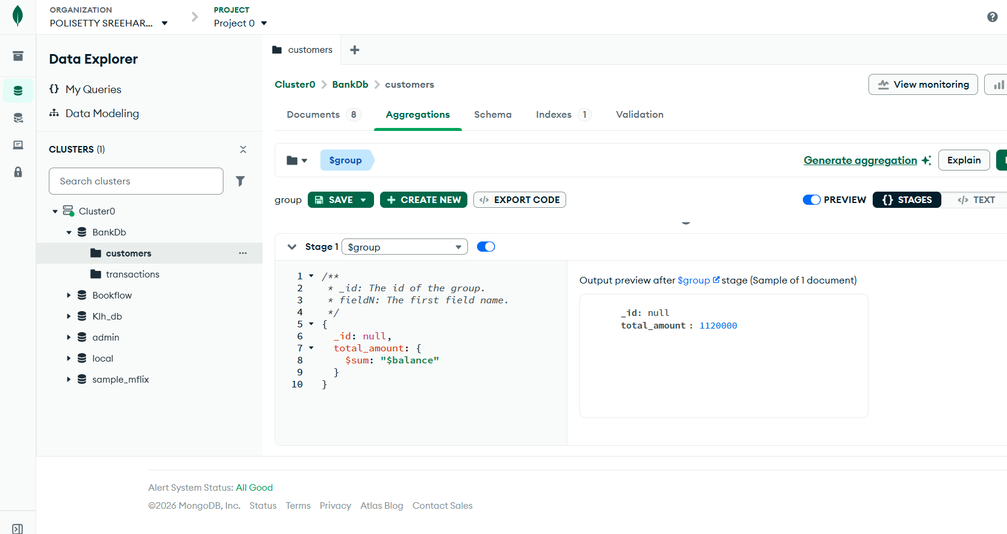
In transactions:
